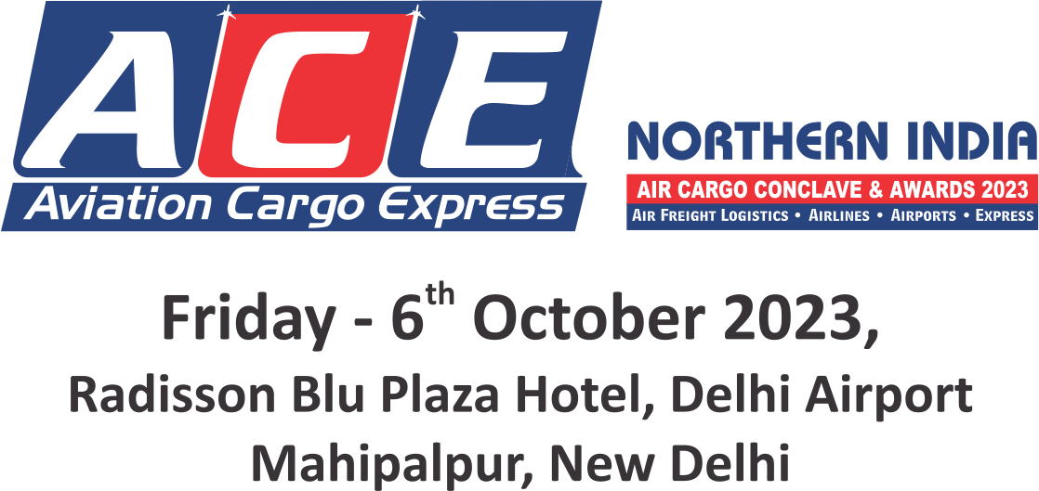

ENTRY FORM FOR NOMINATIONS**
We are inviting companies to submit entries describing how they have demonstrated innovations and excellence or improved their services Or product offering within the regions.
Entries will be evaluated against the set of criteria by panels of judges who will select and shortlist the winner for each category.
Qualifying Period : April 2021 to March 2022 & April 2022 to March 2023
Region : Delhi & Northern India
Categories (Please tick your nominated category):
☐ AIRPORT OF THE YEAR | ☐ IT & SOFTWARE COMPANY OF THE YEAR
☐ AIRLINE / CARGO FREIGHTER OF THE YEAR | ☐ DIGITAL FREIGHT SOLUTION PROVIDER OF THE YEAR
☐ INTERNATIONAL AIRLINE OF THE YEAR | ☐ DIGITAL FREIGHT FORWARDER OF THE YEAR
☐ INDIAN AIRLINE OF THE YEAR | ☐ COLD CHAIN LOGISTICS COMPANY OF THE YEAR
☐ AIR CARGO GENERAL SALES AGENT OF THE YEAR | ☐ WAREHOUSE & SUPPLY CHAIN LOGISTICS COMPANY  OF THE YEAR
☐ AIR CARGO CHARTER OF THE YEAR | STANDALONE CATEGORY
☐ GROUND HANDLING AGENT OF THE YEAR | ☐ YOUNG AIRCARGO PROFESSIONAL OF THE YEAR*
☐ GREEN FIELD AIR FREIGHT STATION OF THE YEAR | ☐ DYNAMIC AIRLINE PERSONALITY OF THE YEAR*
☐ AIRFREIGHT FORWARDER OF THE YEAR  (AIR EXPORT / AIR IMPORT) | ☐ DYNAMIC AIRCARGO PROFESSIONAL OF THE YEAR*
☐ HEAVY LIFT AND OVERSIZE AIR CARGO FORWARDER  OF THE YEAR | ☐ DYNAMIC AIRCARGO LOGISTICS PROFESSIONAL  OF THE YEAR - SHIPPER*
☐ CUSTOMS BROKER OF THE YEAR (AIR EXPORT / AIR IMPORT) | ☐ DYNAMIC AIRPORT PERSONALITY OF THE YEAR*
☐ AIR FREIGHT CONSOLIDATOR OF THE YEAR | ☐ WOMAN PROFESSIONAL OF THE YEAR (AIR CARGO / AIR LINE)*
☐ COURIER / EXPRESS SERVICE PROVIDER OF THE YEAR | ☐ LIFETIME ACHIEVEMENT AWARD (PUBLIC / PRIVATE)*
☐ CUSTOMS BONDED TRUCK OPERATOR OF THE YEAR

**The Jury / Organisers reserve the right to make changes to the list of categories if required; due to lack of sufficient nominations / dearth of information, etc. The decision of the Jury / Organisers will be final & binding.
Kindly click on the box for selected categories * Self Nomination & Suggestions / Recommendations are must
To submit nominations in more than one category, use separate forms

forms

NOMINEE:
Name of the Person
Name of the Company:
Address:
Telephone Number:
E-mail Address:
NOMINATED BY:
Name of the Person:
Name of the Company:
Address:
Telephone Number:
E-mail Address:
Describe the achievements in not more than 500 words:

- Supporting Documents: Only a limited amount of supporting documents may be submitted. (Eg. Relevant Certificates and Documents pertaining to specified criteria norms only.)
- Electronically completed entry should be mailed to : nominations@exim-india.com
- Note: No entries will be accepted in hard copy.

NOMINATION DEADLINE: FRIDAY, 25th AUGUST 2023

