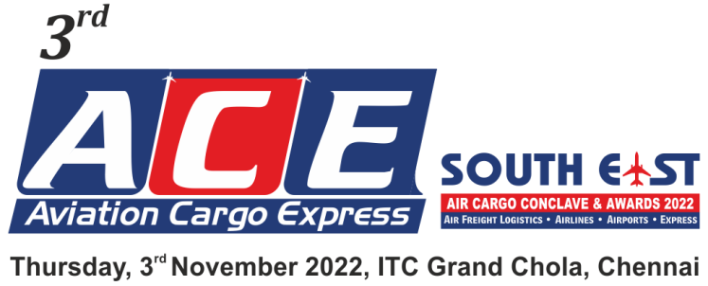

ENTRY FORM FOR NOMINATIONS**
We are inviting companies to submit entries describing how they have demonstrated innovations and excellence or improved their services Or product offering within the regions.
Entries will be evaluated against the set of criteria by panels of judges who will select and shortlist the winner for each category.
Qualifying Period : April 2020 to March 2021 & April 2021 to March 2022
Region : South East India
Categories (Please tick your nominated category):
☐ AIRPORT OF THE YEAR | BENGALURU REGION
☐ INTERNATIONAL AIRLINE / CARGO FREIGHTER /  INDIAN AIRLINE OF THE YEAR | ☐ AIRFREIGHT FORWARDER OF THE YEAR
☐ AIR CARGO GENERAL SALES AGENT OF THE YEAR | ☐ CUSTOMS BROKER OF THE YEAR
☐ GROUND HANDLING AGENT OF THE YEAR | HYDERABAD REGION
☐ AIRCARGO CHARTERING AGENT OF THE YEAR | ☐ AIRFREIGHT FORWARDER OF THE YEAR
☐ AIRFREIGHT FORWARDER OF THE YEAR | ☐ CUSTOMS BROKER OF THE YEAR
☐ AIRFREIGHT CONSOLIDATOR OF THE YEAR | STANDALONE CATEGORY
☐ CUSTOMS BROKER OF THE YEAR  (AIR EXPORT / AIR IMPORT) | ☐ YOUNG AIRCARGO PROFESSIONAL OF THE YEAR*
☐ COURIER / EXPRESS SERVICE PROVIDER OF THE YEAR | ☐ DYNAMIC AIRLINE PERSONALITY OF THE YEAR*
☐ TRANSPORT OPERATOR OF THE YEAR  (BONDED / NON BONDED) | ☐ DYNAMIC AIRCARGO PROFESSIONAL OF THE YEAR*
☐ IT & SOFTWARE COMPANY OF THE YEAR | ☐ DYNAMIC AIRCARGO LOGISTICS PROFESSIONAL OF  THE YEAR - SHIPPER*
 | ☐ LIFETIME ACHIEVEMENT AWARD*

**The Jury / Organisers reserve the right to make changes to the list of categories if required; due to lack of sufficient nominations / dearth of information, etc. The decision of the Jury / Organisers will be final & binding.
Kindly click on the box for selected categories * Self Nomination & Suggestions / Recommendations are must
To submit nominations in more than one category, use separate forms

forms

NOMINEE:
Name of the Person
Name of the Company:
Address:
Telephone Number:
E-mail Address:
NOMINATED BY:
Name of the Person:
Name of the Company:
Address:
Telephone Number:
E-mail Address:
Describe the achievements in not more than 500 words:

- Supporting Documents: Only a limited amount of supporting documents may be submitted. (Eg. Relevant Certificates and Documents pertaining to specified criteria norms only.)
- Electronically completed entry should be mailed to : eximnominations@exim-india.com
- Note: No entries will be accepted in hard copy.
NOMINATION DEADLINE: THURSDAY, 25th AUGUST 2022

