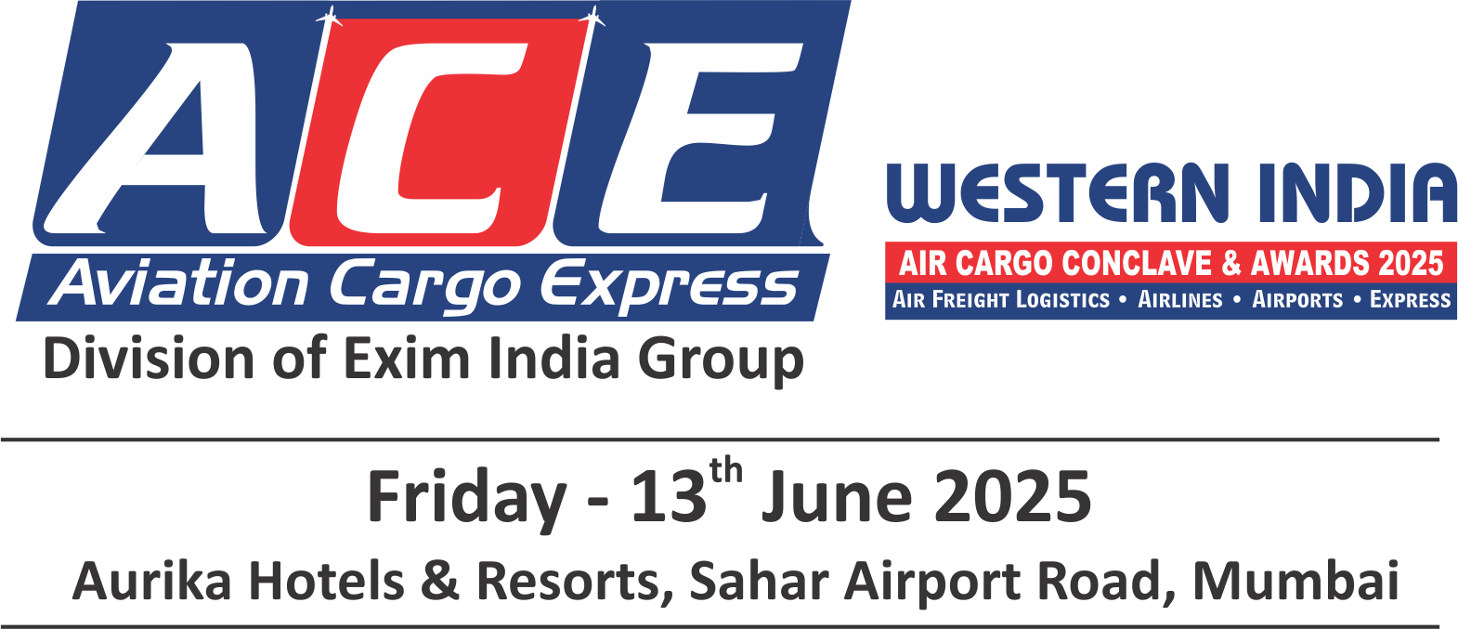

**ENTRY FORM FOR NOMINATIONS\*\***

We are inviting companies to submit entries describing how they have demonstrated innovations and excellence or improved their services or product offering within the regions.

Entries will be evaluated against the set of criteria by panels of judges who will select and shortlist the winner for each category.

**Qualifying Period:** April 2023 to March 2024 & April 2024 to March 2025  
**Region :** Western Region (Goa, Gujarat, Maharashtra)   
**Categories (Please tick your nominated category):**

|  |  |
| --- | --- |
| AIRPORT OF THE YEAR | CUSTOMS BONDED TRUCK OPERATOR OF THE YEAR |
| CARGO FREIGHTER OF THE YEAR | IT & SOFTWARE COMPANY OF THE YEAR |
| AIRLINE OF THE YEAR (INTERNATIONAL / INDIAN) | DIGITAL FREIGHT SOLUTION PROVIDER OF THE YEAR |
| AIR CARGO GENERAL SALES AGENT OF THE YEAR | **STANDALONE AWARDS** |
| AIR CARGO CHARTER OF THE YEAR | YOUNG AIR CARGO PROFESSIONAL OF THE YEAR* |
| AIR CARGO TERMINAL OPERATOR OF THE YEAR | DYNAMIC PROFESSIONAL OF THE YEAR (AIR CARGO /   AIRLINE)* |
| AIRFREIGHT FORWARDER OF THE YEAR (AIR EXPORT / AIR   IMPORT) | DYNAMIC AIR CARGO LOGISTICS PROFESSIONAL OF THE   YEAR - SHIPPER* |
| HEAVYLIFT AND OVERSIZE AIR CARGO FORWARDER OF  THE YEAR | WOMAN PROFESSIONAL OF THE YEAR (AIR CARGO /   AIRLINE)* |
| CUSTOMS BROKER OF THE YEAR (AIR EXPORT / AIR   IMPORT) | ☐ LIFETIME ACHIEVEMENT AWARD (PUBLIC / PRIVATE)* |
| COURIER / EXPRESS SERVICE PROVIDER OF THE YEAR |  |

**The Jury / Organisers reserve the right to make changes to the list of categories if required; due to lack of sufficient nominations / dearth of information, etc. The decision of the Jury / Organisers will be final & binding.

**Kindly click on the box for selected categories** * Self Nomination & Suggestions / Recommendations are must

**To submit nominations in more than one category, use separate forms**

**forms**

**NOMINEE:**

Name of the Person:

Name of the Company:

Address:

Telephone Number:

E-mail Address:

**NOMINATED BY:**

Name of the Person:

Name of the Company:

Address:

Telephone Number:

E-mail Address:

Describe the achievements in not more than 500 words:

* Supporting Documents: Only a limited amount of supporting documents may be submitted. (Eg. Relevant Certificates and Documents pertaining to specified criteria norms only.)
* Electronically completed entry should be mailed to : nominations@exim-india.com
* **Note:** No entries will be accepted in hard copy.

**NOMINATION DEADLINE: WEDNESDAY, 30th APRIL 2025**